**Evaluate custom vision model metrics**

After training is complete, you can view the model's performance evaluation. The following metrics are used:

* Image classification: Average Precision, Accuracy Top 1, Accuracy Top 5
* Object detection: Mean Average Precision @ 30, Mean Average Precision @ 50, Mean Average Precision @ 75

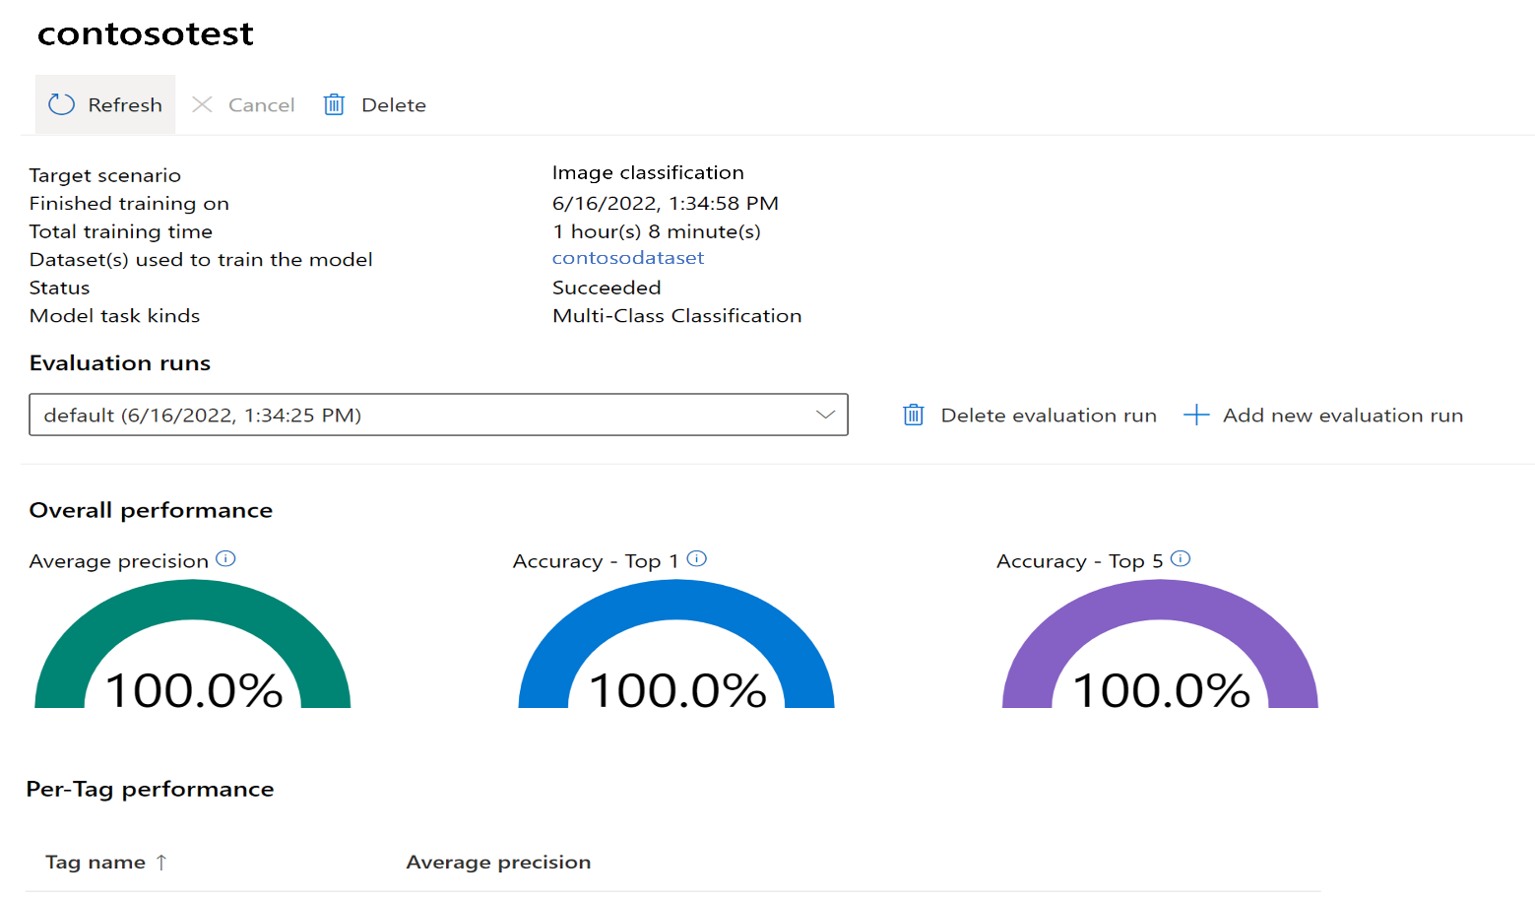

1. Go to custom vision model

1. Go through all the fields to understand.

1. By default, it uses subset of training images to perform testing.

1. Now test with test images model.

The quality of your classifier or object detector model built with Azure AI Custom Vision depends on the amount, quality, and variety of the labeled data you provide when training the model. The quality also depends on how balanced the overall dataset is between classes.

After you've trained your model, you can see the estimate of the project's performance [customvision.ai](http://customvision.ai/). Custom Vision uses the images that you submitted for training to estimate precision, recall, and mean average precision. These three measurements of an image classifier’s effectiveness are defined as follows:

* **Precision** is the percentage of identified classifications that were correct. For example, if the model identified 100 images as dogs, and 99 of them were actually of dogs, then the precision is 99 percent.
* **Recall** is the percentage of actual classifications that were correctly identified. For example, if there were actually 100 images of apples, and the model identified 80 as apples, the recall is 80 percent.
* **Mean average** precision (mAP) is the average value of the average precision (AP). AP is the area under the precision/recall curve (precision plotted against recall for each prediction made).

Probability threshold is the desired level of confidence that a prediction needs to have in order to be considered correct. When you interpret prediction calls with a high probability threshold, they tend to return results with high precision at the expense of recall. That is, the detected classifications are correct, but many remain undetected. A low probability threshold does the opposite: most of the actual classifications are detected, but there are more false positives within that set. With this in mind, you should set the probability threshold according to the specific needs of your project. By default, the probability threshold is 50% and can be set between 0% and 100%. To adjust the probability threshold, go to [customvision.ai](http://customvision.ai/) on the **Performance** tab, find the **Probability Threshold** slider, and adjust it to your needs.